- Practice graphics & short description
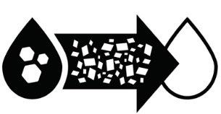 | 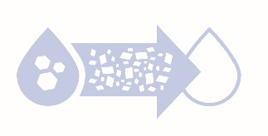 | 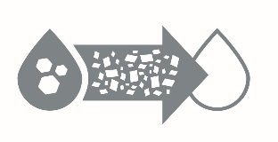
Bioreactor: Redirects tile water to an underground bed of wood chips where nitrate is removed naturally by microorganisms. Vegetation on top of the bioreactor can provide other benefits such as wildlife habitat.

- Short article
Bioreactor — Underground Filtration to Reduce Nitrate
A bioreactor is an edge-of-field treatment process that allows the producer to reduce the amount of nitrate leaving the field from a tile line and therefore improve water quality of the receiving stream. A bioreactor consists of a buried pit filled with a carbon source--such as wood chips-- through which tile water is diverted. The carbon provides a food source for microorganisms that use the nitrate to metabolize the carbon, converting the nitrate to harmless gas.

The Benefits
In addition to improved fertilizer management, tillage management, and wetland restoration, bioreactors help improve water quality by reducing nitrate that naturally occurs in agricultural drainage water. Bioreactors can reduce nitrate by an average of 43 percent and have proven to work well in existing filter strips as well as in other locations.

(Insert farmer testimonial) Example:
(insert name) has installed a bioreactor. (insert last name/location). “I’ve seen a reduction of xx nitrate in the outbound water.”

What’s Next
To date, about 60 bioreactors have been installed in Iowa. It is estimated Iowa needs roughly 120,000 bioreactors to reach the goals set out in the Iowa Nutrient Reduction Strategy. We need more farmers to get on board and try bioreactors to help scale up the impact of their effect on overall water quality. Want to be part of the solution? Contact XXXXX to learn more and find out how to design and install your own bioreactor.

- Longer article – technical
A bioreactor is an edge-of-field treatment process that allows the producer to reduce the amount of nitrate leaving the field from a tile line and therefore improve water quality of the receiving stream. A bioreactor consists of a buried pit filled with a carbon source--such as wood chips-- through which tile water is diverted. The carbon provides a food source for microorganisms that use the nitrate to metabolize the carbon, converting the nitrate to harmless atmospheric nitrogen (N2) gas.

In addition to improved fertilizer management, tillage management, and wetland restoration, bioreactors help improve water quality by reducing nitrate that naturally occurs in agricultural drainage water. Bioreactors can reduce nitrate by an average of 43 percent and have proven to work well in existing filter strips or in other locations.

Bioreactors offer a relatively high rate of nitrate removal with a small footprint on the landscape. They require very little maintenance during their lifecycle and a number of programs are available to offset much of the cost.

To date, about 60 bioreactors have been installed in Iowa. It is estimated that Iowa needs roughly 120,000 bioreactors to reach the goals set out in the Iowa Nutrient Reduction Strategy. We need more farmers to try them. Want to be part of the solution? Contact the Iowa Soybean Association Environmental Programs and Services team or your local Soil and Water Conservation District office to learn more.

- Social Media Posts
TWITTER
#Bioreactors are a good way to support #waterquality in Iowa. While they sound complicated, learn about how effective they are.

Iowa has currently built 60 bioreactors, but needs 120,000 to reach our goals! Can you help meet this important #waterquality goal by building one on your land?

We’re hosting a #bioreactor field day. Farmer-to-farmer learning is key with new practices to improve #waterquality. Join us (add date and location details)!

#Bioreactors are an underground bed of wood chips that turn #nitrate into a harm-free gas. Learn more about this low-cost, low-maintenance option!

FACEBOOK POST
Bioreactors are an underground bed of wood chips that improve water quality by reducing nitrate concentration in stream water. Learn more about this low-cost, low-maintenance option!

